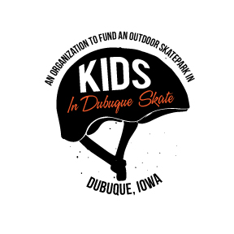 Kids in Dubuque Skate
4927 Wild Flower Drive ⬤ Dubuque, IA 52002 ⬤ Phone: (563) 583-7128 ⬤ kidsindubuqueskate.com
Directors:  Laura Bies  President  Mike Heitz  Vice-President  Jennifer Tigges  Public Relations  James Kelly  Treasurer  Deborah Schmidt  Event Coordinator  Ben Kahle  Research & Development  Jason Henkel  Marketing  Adam Riegler  Campaign Coordinator |  | Dear _________________  A New Outdoor Skatepark is Coming to Flora Park!  Kids in Dubuque Skate (K.I.D.S.) is a grassroots community group, formed in 2005. Both youth and adults saw the need for a new skatepark due to the poor condition of the existing park at MacAleece, the remote location on Chaplain Schmitt Island, and lack of water fountains or restrooms. The City of Dubuque has committed $600,000 to build a new skatepark to serve the action sports community including citizens who ride skateboards, scooters, bikes and rollerblades.  The mission of KIDS is to help establish a premier outdoor skatepark, designed with community input, to satisfy the needs of skaters and the community while encouraging youth and participant involvement in the civic process. This new park will provide a place for athletes to learn coordination skills, make new friends, express their creativity, learn self-respect and respect for others, and stay healthy through physical exercise in a safe, low-maintenance, wheelchair-accessible, concrete skatepark.  We are excited that the city council approved the site selection at Flora Park in 2017 and the final design documents for the new skatepark are in process!  Now it’s your turn.  We have been challenged by the City to raise $225,000 to bring the total project budget to $825,000. KIDS is looking for your support to help us lead the campaign to fulfill our commitment as a community to raise the additional funds needed by May 1, 2018 so the city can break ground on this landmark project in summer 2018!  As a future skatepark user, I am very excited about this project and hope that you can support me as I help with this fundraising effort. Please consider helping us finish this project with your tax-deductible donation or in-kind donation. To donate go to www.kidsindubuqueskate.com or www.dbqfoundation.org/kidsindubuqueskate or contact us for a hard copy of the giving form.  Please feel free to contact us with any questions. We look forward to hearing from you soon!  Best Regards,  Kids in Dubuque Skate
“Friends helping our community realize a dream.”

